Software Requirements Specification

PRJ566 – Fall 2024

Process and Data Modeling

3.1 Business Rules
Business Rule Number | Business Rule Description | Related UC
BR01 | User must provide a valid and unique user email and password to register for the application. | UC02
BR02 | Password length must be atleast 10 characters long and less than or equal to 16 characters. | UC02
BR03 | Password characters permitted are: Alphabets, Number and special characters: /,@,!,$ | UC02
BR04 | User must enter valid user email and password, and user should have already signed up with that email, to gain access to the application | UC01

3.2 UML/DFD Modeling and Data Modeling

Use Case Specifications with corresponding interface mockups:

Each use case needs to have the following:

1- System Use Case Diagrams.
2- Use Case Descriptions.
3- Corresponding Mockups

1) Sign Up
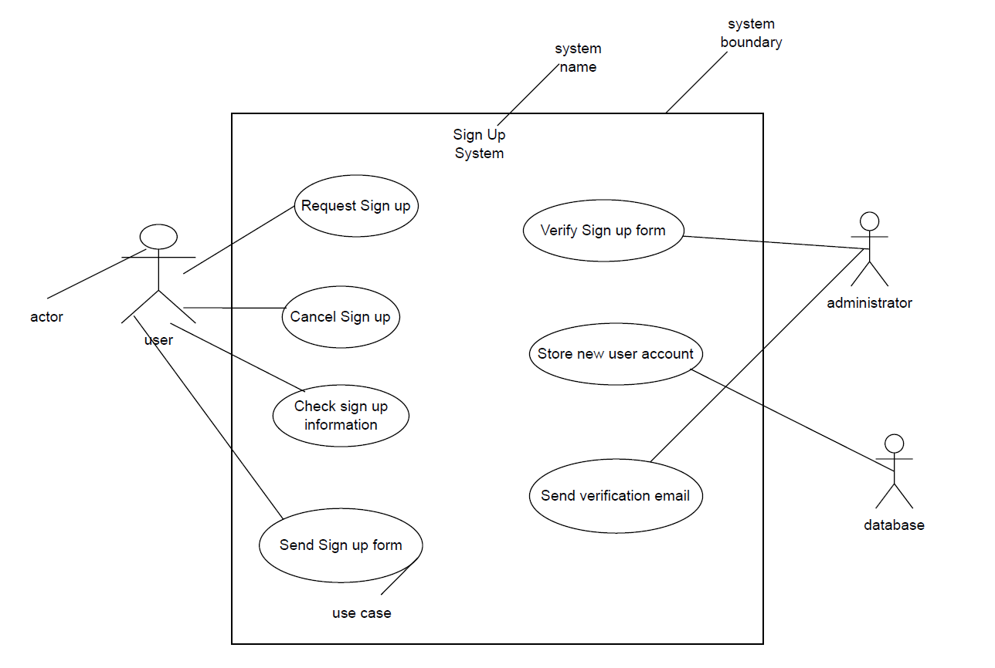
Use Case Name: Sign up | Id: 2 |  | Importance Level: High
Primary Actor: Users |  | Use Cast Type: Detail, Essential
Stakeholders and Interest:
User – want to create their own account for interaction with application
Application administrator - Wants to manage user accounts effectively, and ensure security.
Brief Description:
This use case describes how the new users create their own account in our application.

Trigger: New users call the sign up
Type: External

Relationships:
Association: Users
Include: Password strength check
Exclude: Account recovery
Generalization: User Registration

Number Flow of Events:
1. The user navigates to the sign-up page of the application.
2. The user fills out the sign-up form, providing required information such as: Username, Email, Password
3. The user clicks the "Sign Up" button to submit their information.
4. The application checks the entered information for validity, ensuring all required filed are filled and the email address is valid
5. The application verifies if the email or username already exists in the database
6. The user checks their email and clicks on the verification link.
7. The application displays a success message confirming the account creation.

SubFlows:
Alternate/Exceptional Flows:
S-1: Password Strength Check SubFlow:
- The application evaluates the entered password against defined strength criteria (length, character variety, etc.).
- If the password does not meet criteria, the application displays a message prompting the user to create a stronger password.

S-2: Email Verification SubFlow:
- The application generates a unique verification token.
- The application sends a verification email to the user with the token embedded in a link.
- The user clicks the verification link in the email.
- The application verifies the token and activates the user account.
- The application displays a success message and allows the user to log in.

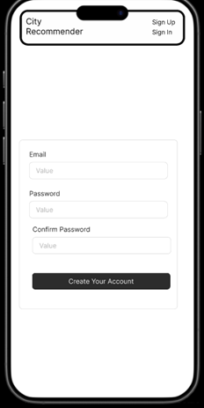
2) Sign In
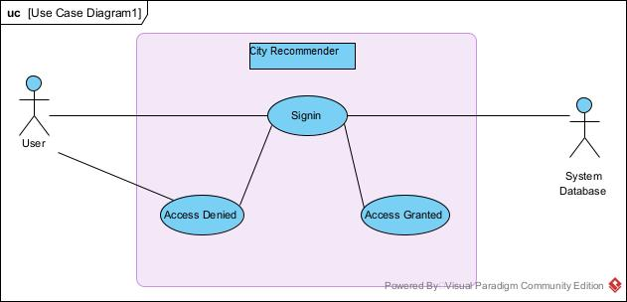
Use Case Name: Sign in to City Recommender |  | ID: 2 | Importance Level: Medium
Primary Actor: User | Use Case Type: Detail, Essential
Stakeholders and Interests:
User: Wants to login into user account to start using City Recommender.
System: Aims to validate the account details and sign into account and allow user to gain access to the account.
Brief Description: This use case describes the process of users signing into their account, in order to use City Recommender Application.
Trigger: User initiates the action to sign into account through the application interface. Type: Internal
Relationships:
Association: User
Extend: N/A
Include: N/A
Generalization: N/A
Normal Flow of Events:
User accesses the Account section of the application.
User provides the necessary details for the login, user email (unique and required), and password(required).
System accepts input and validates the data: User email should exist in users database, and the password should match the password in the database.
System grants access to the user with all the user information loaded in the application.
Subflows: Retrieve user's information from the database.
Alternate/Exceptional Flows:
User tries to login with invalid credentials.
System prompts the user to enter valid credentials.

User enters invalid user email.
System prompts the user that the user email does not exist and instructs to sign up instead.

User enters a valid user email and an invalid password.
System prompts the user that the password is incorrect and instructs to try again.

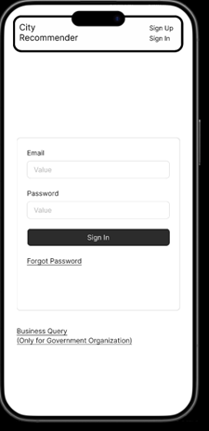

Domain Class Diagram

Database

Work Breakdown Structure (WBS)

Work Breakdown Structure
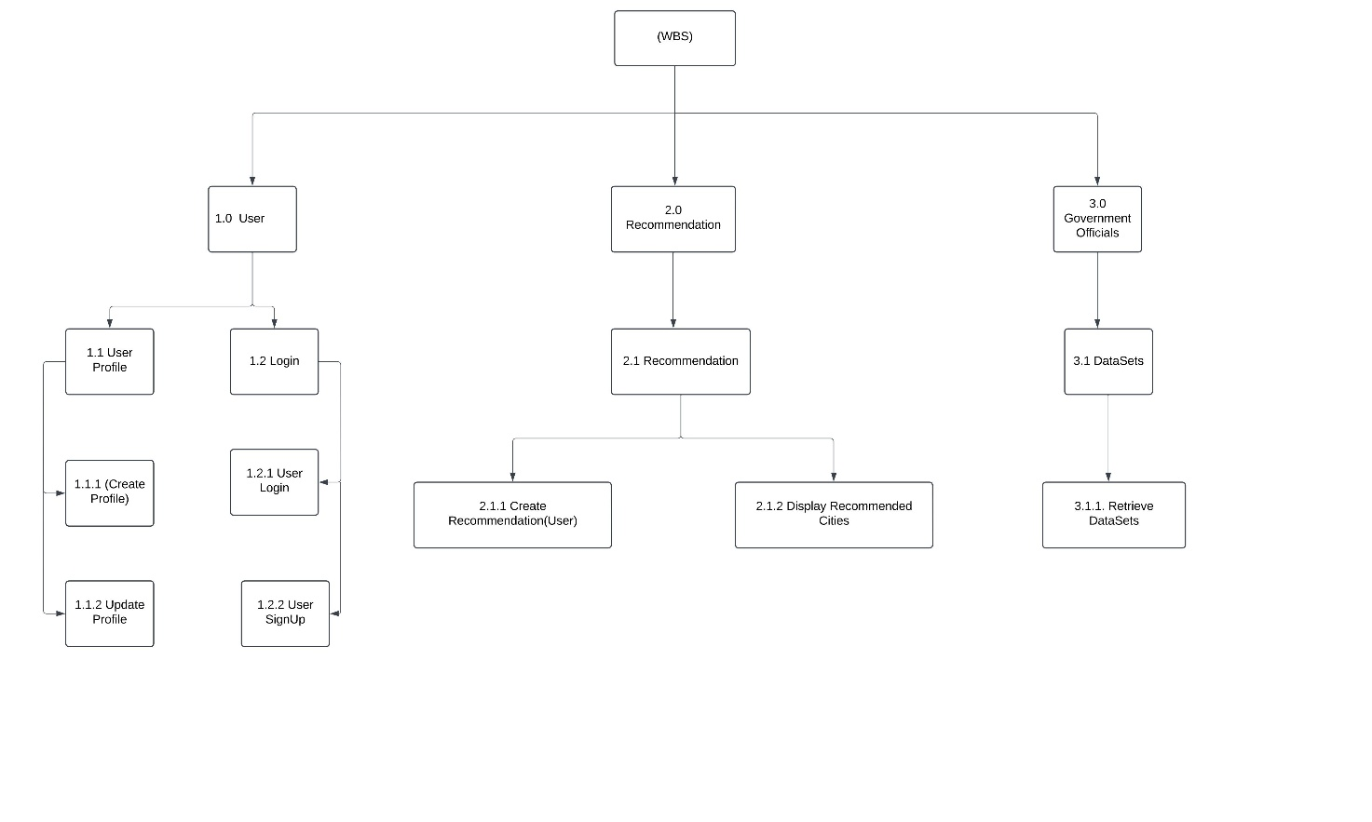

Implementation Schedule
I Product Backlog
Sprint 1
Getting Recommendation (Machine Learning Model)
Duration | Jan 2025 to Feb 2025
Goals | - Implement the Machine Learning Model for recommendation.  - Finalize the UI/UX Figma Design.
Scope
  Task | Setting up the backend server and integrate with ML model and API Integration with Frontend.
  Milestone | ML Model Development by Feb 20.  API Integration by Feb 20.
Risk | The required datasets might not be available or accessible within the sprint timeline.

Sprint 2
User Registration and Login
Duration | Feb 2025 to Feb 2025
Goals | Implement the registration system for user registration.
Scope
  Task | Create a database and store the user login credentials.  Implement the login and user registration functionality.
  Milestone | User Registration and login features by Feb 30.
Risk

Sprint 3
Implement Frontend
Duration | March 2025 to April 2025
Goals | Finalize frontend for our application
Scope
  Task | Complete the frontend for the application.  Implement all the servers to communicate via Rest API.
  Milestone | Complete Frontend by March 10.  Develop Rest API by March 15.
Risk

Sprint 4
Backend functionality
Duration | Feb 2025 to March 2025
Goals | Implement backend functionality to perform user specified tasks
Scope
  Task | Create the backend server and user interaction functionality of the application
  Milestone | Develop the backend by Mid-March.
Risk

Sprint 5
Dataset access functionality for Canadian officials
Duration | April 2025
Goals | Add the features to get the dataset of the users to the Canadian Officials
Scope
  Task | Develop a functionality to access the data sets for Canadians  Officials.  Implement all the servers to communicate via Rest API.
  Milestone | Accessing dataset feature and Developing Rest API by April.
Risk

ID | User Stories | Priority | Sprint
1 | As a user, I want to be able to create an account using signup | 4 | 2
2 | As a user, I want to be able to login to my account and use the application | 4 | 2
3 | As a user, I should be able to store my account details in the application | 4 | 3
4 | As a user, I want to set my preferences for cities when requesting a recommendation | 3 | 4
5 | As a user, I would like the application to generate a list of cities best suitable for me based on my information | 5 | 1
6 | As a user, I want the application to allow me to generate multiple recommendations based on different information I provide. | 5 | 4
7 | As a user, I should be able to check the recommended cities list whenever I log back into the application | 3 | 4
8 | As a Government Official, I want to be able to access the user data. | 2 | 5

Client / Faculty Sign-off

Date: ______________________

X .
Name of Client/Rep/Professor

